**Testing for Sensitive Data in Local Storage**

**Shared Preferences**

[Shared Preferences](http://developer.android.com/reference/android/content/SharedPreferences.html) is a common approach to store Key/Value pairs persistently in the filesystem by using an XML structure. Within an activity the following code might be used to store sensitive information like a username and a password:

|  |  |
| --- | --- |
|  | **Note:**  **Ensure that you are performing this activity on a rooted Android Phone** |

1. Launch Android Studio
2. Navigate to Tools > Android > SDK Manager > Copy Android SDK Location
3. Open command prompt and navigate to below path where Android SDK platform tools are located

**C:\Users\venugopal.madinoor\AppData\Local\Android\Sdk**

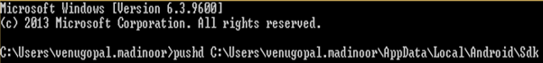

1. Use below command to check the connected android devices.

**adb devices**

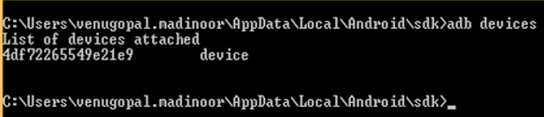

1. Type the below command to get into “adb shell” mode.

**adb shell**

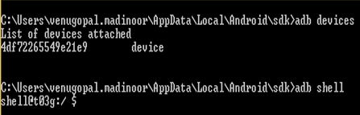

1. Navigate to root by using “**su**” command

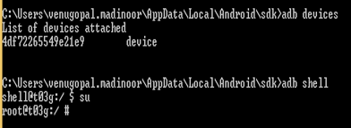

1. Using root privileges, navigate to the **shared_prefs** folder of the app and find the list of files available in the shared_prefs folder

* **cd /data/data/com.sololearn/shared_prefs/**
* **ls**

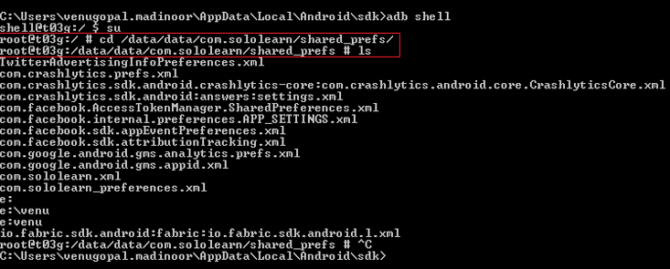

1. Exit from root and in ‘shell’ -type the below command to copy the files from shared_prefs folder to sdcard/Download folder.

**cp /data/data/com.sololearn/shared_prefs/*.xml /sdcard/Download**

1. Now exit from shell and use the below command to copy the files from sdcard to Desktop location

**adb pull /sdcard/Download/com.sololearn.xml E:\venu**

1. After copying to the desktop, analyze the file to see if there are any sensitive information.